**FMB Sketch**

* The workshop for FMB Sketch was conducted on 01-10-2021 by M.Shanmugaraj, Senior Lecturer / Civil, VSVN Polytechnic College, Virudhunagar.
* He stated that how to obtain FMB sketch from TN e services or Collabland or to request the concerned Tahsildar office to survey the property, next we discussed about Components of FMB such as G-line, F-line, Subdivision lines, Ladder, Extension lines, Neighboring field survey numbers and finally he stated how to import FMB sketch in AutoCad and make measurement.

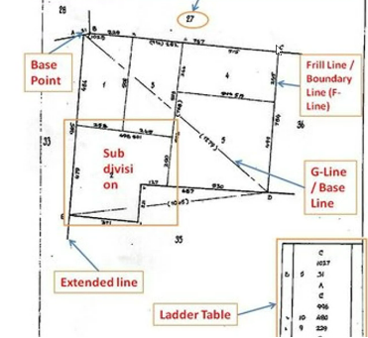

**FMB Sketch**